Space One Eleven
ALABAMA CHARCOAL SPRING 2014

Alabama Charcoal is a project of Space One Eleven’s (SOE) successful flagship program City Center Art (CCA), offering rigorous drawing and portfolio development classes focusing on college/career planning in the fields of art and design. Alabama Charcoal is a Portfolio Development and College Readiness program dedicated to helping high school students increase their college opportunities though competitive visual art portfolios and technical drawing skills. Students will develop their technical skills by gestural charcoal and ink drawing from direct observation. The critique is central to Alabama Charcoal because it teaches students to be self-reflective and engage in the individual process of art making. Alabama Charcoal will provide portfolio critiques by visiting artists, and personalized assignments to complete an accomplished college portfolio. Students will also receive help with their college applications, scholarships and essays. The program meets in Space One Eleven’s professional painting studios at 2409 2nd Ave North, Birmingham.
Alabama Charcoal will accept approximately 15 students in Portfolio and Drawing classes for the 2014 school year.
For more information contact Tara Lee, taralee@spaceoneeleven.org or 205-328-0553 ext. 24

Alabama Charcoal students work on personal projects while mentors offer their knowledge.
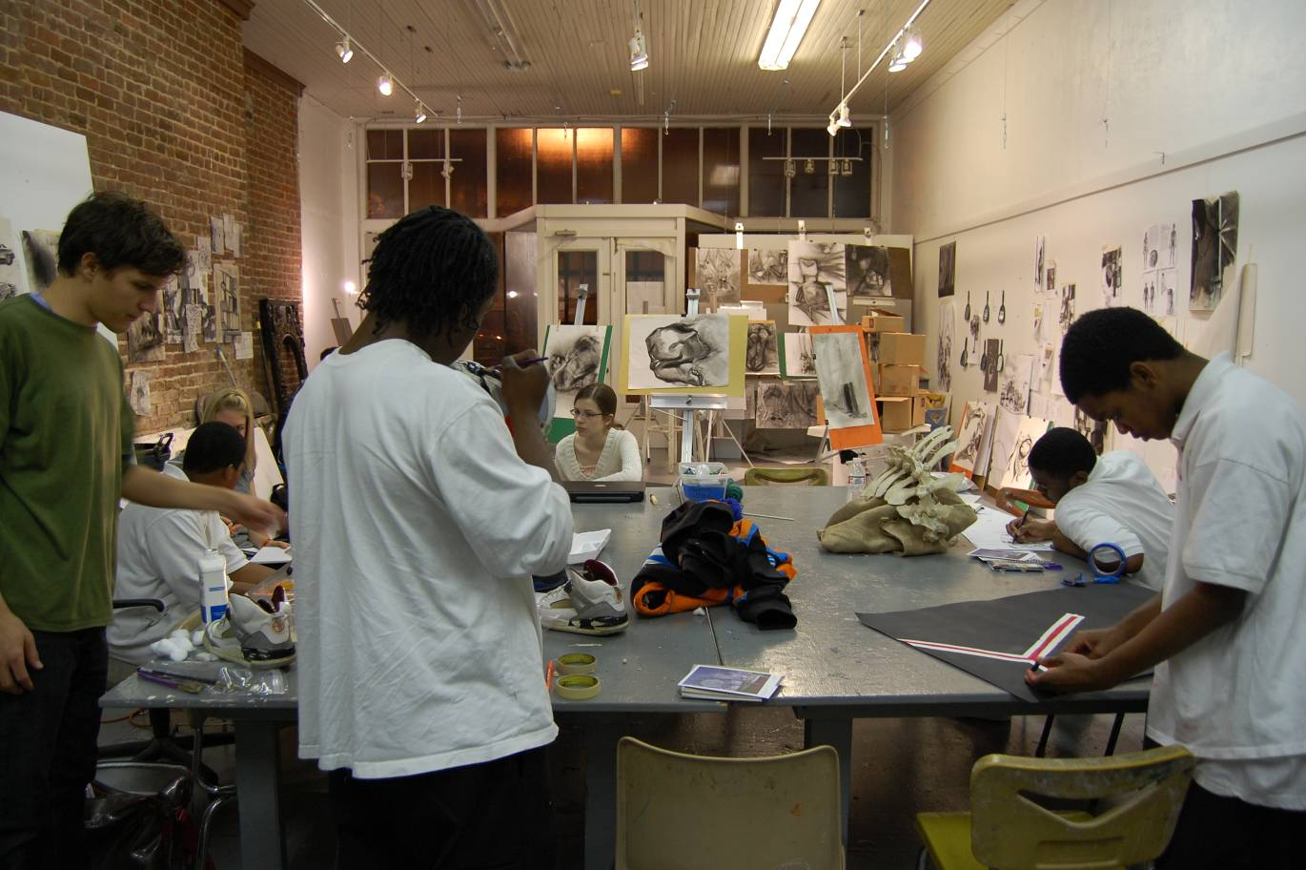

Pht

Classes begin Tuesday, January 14, 2014 from 4:15pm-6:15pm.

Space One Eleven
ALABAMA CHARCOAL SPRING 2014
Application for Scholarship/Tuition Assistance
All income information provided here is voluntary and optional. However, if you choose not to provide income information, we cannot offer you scholarship/tuition assistance.

Student Personal Information
First Name, Last Name, and MI | Date of Birth | M/F | School Name | Grade | Principal’s Name
Address and Contact Information
Parent’s/ Guardian’s Name_____________________________________________________________
Relation to Child_____________________________________________________________________
Address: (Street) ________________________________________________________Apt #________
(City) _________________________________________ (State) _______ (Zip) __________________
(Community i.e. Woodlawn)_______________________email address__________________________
Please check the preferred number to call
Home/Cell Phone: ___________________________ Work Phone________________________

Total Household Income from Last Year:
Less than $20,000 $20,001-$30,000 $30,001-$40,000
$40,001-$50,000 $50,001-$60,000 $60,001-$70,000
$70,001-$80,000 $80,001-$90,000 over $90,001
HOUSE HOLD SIZE ________(include everyone that lives at your residence)

For additional scholarship consideration:
Do you qualify for Free/Reduced Lunch?
Free Lunch Reduced Lunch
Is your school designated as Title 1:
Yes No

Privacy Act Statement: This explains how we will use the information you give us. You do not have to give the information, but if you do not, we cannot approve your child for free or reduced price art programs. We will use your information to determine if your child is eligible for free or reduced fee art programs. We MAY share your eligibility information with education, health, and nutrition programs to help them evaluate, fund, or determine benefits for their programs, auditors for program reviews, and law enforcement officials to help them look into violations of program rules. Part

Please check the ethnicity of your child. (Providing this information will help us with evaluation requirements by some funders, but you are not required to answer this question.)
____White, not Hispanic ____African American ____Hispanic ____Asian/ Pacific Islander
____ American Indian/Alaskan Native ____Other please describe____________________________________________

Special Medical Needs: (Will be kept confidential)
Special Medical Issues that would be beneficial to SOE’s knowledge: ____________________________________________________________________________________________________________________________________________________________________________________
Allergies:____________________________________________________________________________________________________________________________________________________________________________
Medications taken on a regular basis: ___________________________________________________________
Other possible concerns: _____________________________________________________________________
__________________________________________________________________________________________

Emergency Contacts Personal Information
Child MAY be released to:
Name_____________________________________ Phone Number ___________________________
Name_____________________________________ Phone Number ___________________________
Name_____________________________________ Phone Number ___________________________
Child MAY NOT be released to:
Name_____________________________________ Phone Number ___________________________
Name_____________________________________ Phone Number ___________________________

In the event of an emergency and the parent/guardian or Emergency Contact is not available, does Space One Eleven have permission to secure emergency medical treatment? YesNo

How did you find out about Space One Eleven’s City Center Arts Program?______________________
Have you participated in a Space One Eleven’s City Center Arts Program before? _________________
If yes, what year(s)?__________________________________________________________________
I certify (promise) that all information on this application is true and that all income is reported. I understand that if I purposely give false information, my child may lose program benefits.

3 - Foster Child (Complete only if student listed above is a FOSTER CHILD - Use a separate application for each Foster Child)
X ____________________________________
Signature (an adult household member must sign the application) Printed First and Last Name DATE

FOR OFFICE USE ONLY
Total Income:________ Per:_____ Week,____ Every 2 Weeks,_____ Once a Month______ Household Size:_______
Categorical Eligibility (free or tuition assisted)_______________________Temporary: Free_____Reduced______
Time Period______ (expires after _____ days) Determining Official's Signature:_____________________Date_____________
Birmingham District and City Council Members
District 1 Lashunda Scales District 2 Kim Rafferty District 3 Valerie Abbot
District 4 Maxine Parker District 5 Jonathan Austin District 6 Carole Smitherman
District 7 James Robertson, Jr. District 8 Steven Hoyt District 9 Roderick Royal
Jefferson County Commissioner
George Bowman (1) Sandra Little Brown (2) Jimmie Stephens (3) Joe Knight (4) David Carrington (5)
Space One Eleven
ALABAMA CHARCOAL 2014

Check which days you are interested in coming to Space One Eleven (Students are encouraged to attend both):

Tuesdays beginning January 14th, 2014, 4:15-6:15pm
Thursdays beginning January 16th, 2014, 4:15-6:15pm

Students please arrive between 4:00 and 4:15 pm for class depending on transportation time and school dismissal time.

Mentor/Teacher:
Please list the contact information for your current arts mentor or art teacher if applicable:

Name: ____________________________________________________________________________________
School/Organization: ________________________________________________________________________
Street Address______________________________________________________________________________
City:________________________________________________________ Zip: _________________________
Phone Number: ____________________________________________________________________________
Email: ____________________________________________________________________________________

Mentor/Teacher Recommendation:

Please attach a recommendation from your teacher or mentor, or if you do not have an art teacher or mentor, someone who can describe why he/she thinks you should be involved in Space One Eleven’s portfolio preparation program. The recommendation should include descriptions of the student’s current work and areas in which he/she needs help. Recommendations from your parent/guardian are acceptable only if you do not have an art teacher or mentor.
Space One Eleven
ALABAMA CHARCOAL 2014
Art Work Waiver

I (parent/guardian), _________________________, do hereby agree that any artwork produced in whole or in part by (Student’s full name) _________________________ in the Space One Eleven’s art programs, including City Center Art (CCA) and Alabama Charcoal, are and shall remain the property of SOE and that I have no proprietary interest in the said artwork.

Parent’s/Guardian’s Signature __________________________________ Date _______________

Parent/Guardian Consent for Media Release
I (parent/guardian), ______________________________, hereby consent to allow (Student’s full name) ______________________________ to be photographed, videotaped, audio taped, and/or interviewed by the news media during the City Center Art Program. Further, I understand that the photograph, videotape, audiotape, or interview transcript may be posted online and/or may be used for publicity purposes in the future. I/We, as parent(s) or legal guardian(s) of the above named, agree to release and hold harmless SOE, its members, officials, agents, and employees from and against any and all claims, demands, actions, complaints, suits, or other forms of liability that shall arise out of, or by reason of, or be caused by, the use of the image of the individual named above on television, radio, in motions pictures, or in print.
It is further understood and I do agree that no money or other consideration in any form including reimbursement for any expenses incurred by me or the above named will become due to me, the above names, our heir, agents, or assigns at any time because of participation of the above named in any of the above activities.
Student (Please Print)
Student’s Signature _____________________________________ Date
Parent/Guardian (Please Print) ____________________________
I (parent/guardian), ______________________________, DO NOT CONSENT to the above Media Release for (student’s full name) ______________________________________.
Parent’s/Guardian’s Signature _________________________________ Date _______________

MEDICAL, MENTAL, AND PHYSICAL CONDITIONS OR DIETARY PREFERENCES

Student’s Name ____________________________________________________________________________
Primary Physician | Name: | Phone Number: | Location:
Emergency Contact 1 | Name: | Phone Number: | Relationship to child:
Emergency Contact 2
Emergency Contact 3
Emergency Contact 4

Check all that apply Preferred Treatment Emergency Contact
ASTHMA
DIABETES
ALLERGIES:
Nuts/peanut butter
Insects
Penicillin
Animals
Eggs
Dairy
Pork
Face Paint
VEGETARIAN
MENTAL DISABILITY
PHYSICAL DISABLILITY
VISUALLY IMPAIRED
HEARING IMPAIRED
Other Conditions
Medications Taken
Space One Eleven
ALABAMA CHARCOAL 2014
Student Questionnaire

- What are the art opportunities currently available at your school? How many art classes have you taken in high school? Do you feel like you are receiving the technical instruction that you need from your current art teacher at school?

- What areas of art or design most interest you? (Example: graphic design, architecture, painting) What do you do in your spare time? How much previous drawing/design experience have you had prior to this class?

- Do you own a sketchbook? If so, how often do you draw in your sketch-book?

- What schools would you like to attend? What colleges are you thinking about applying to? What major are you considering in college?

- What is your to-do list for college applications?

- Have you begun your college applications? How can we help you?

- What challenges are you now facing in your life? How are you working towards overcoming them? (i.e.; school and academic challenges, home life challenges, artistic challenges, etc.)

- What challenges do you face in attending this program? Transportation? Work? Homework? Family obligations? Please describe these challenges in detail and explain how you will overcome them.

- What does ART mean to you?

- On a day to day basis, in what ways does ART enhance your life? Where do you see ART? Where do you interact with ART? Do you make ART? Do you like ART?

- Describe your personal creative voice and style.

- Do you have any favorite artist? A favorite Art piece? Art movement?

- Have you ever been to an art gallery before? An art museum? If so, where?

- Is there anything you would like to learn that you have not been able to?

- In your own words define:

  - Value

  - Line

  - Gesture

  - Contour

- If you could have any super power, what would it be and why?

- Please draw a blind contour of your own face or the person sitting next to you.

